**- NR Result for 5 Buses - 2024-04-24**

# Power Flow Overview

Iteration Result: Maximum iterations reached without convergence.

Total P losses: 0.027

Total Q losses: -0.108

Total P generation:0.4

Total P loads & losses:1.477

# Bus Parameters

|  |  |  |  |  |  |  |
| --- | --- | --- | --- | --- | --- | --- |
| V | Ang | P_G | Q_G | P_L | Q_L | Bus Type |
| 1.06 | 0.0° | 1.277 | 0.953 | 0.0 | 0.0 | Slack |
| 1.0 | -1.978° | 0.4 | -0.661 | 0.2 | 0.1 | PV |
| 0.986 | -4.467° | 0.0 | 0.0 | 0.45 | 0.15 | PQ |
| 0.983 | -4.771° | 0.0 | 0.0 | 0.4 | 0.05 | PQ |
| 0.972 | -5.535° | 0.0 | 0.0 | 0.6 | 0.1 | PQ |

# Line Parameters

Line Line Currents [p.u.]

1-2: 1.103 ∠-41.904°

1-3: 0.43 ∠-26.581°

2-1: 1.103 ∠138.096°

2-3: 0.239 ∠-2.589°

2-4: 0.27 ∠-4.414°

2-5: 0.533 ∠-10.041°

3-1: 0.43 ∠153.419°

3-2: 0.239 ∠177.411°

3-4: 0.194 ∠-17.995°

4-2: 0.27 ∠175.586°

4-3: 0.194 ∠162.005°

4-5: 0.068 ∠-27.126°

5-2: 0.533 ∠169.959°

5-4: 0.068 ∠152.874°

Line Line Power Flows [p.u.]

1-2: 1.169 ∠41.904°

1-3: 0.455 ∠26.581°

2-1: 1.103 ∠-140.074°

2-3: 0.239 ∠0.611°

2-4: 0.27 ∠2.436°

2-5: 0.533 ∠8.063°

3-1: 0.424 ∠-157.886°

3-2: 0.236 ∠178.121°

3-4: 0.192 ∠13.528°

4-2: 0.266 ∠179.643°

4-3: 0.191 ∠-166.776°

4-5: 0.066 ∠22.354°

5-2: 0.518 ∠-175.494°

5-4: 0.066 ∠-158.409°

# Plots

## Load & Generation Plot

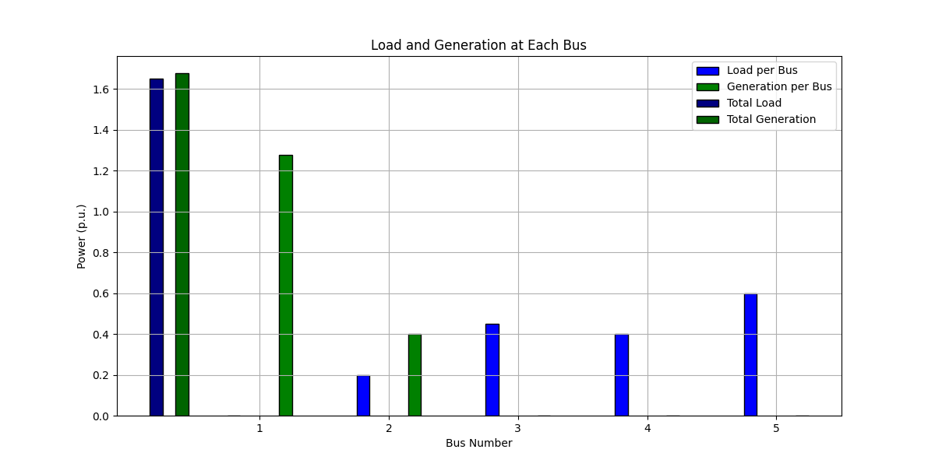

## Network Plot

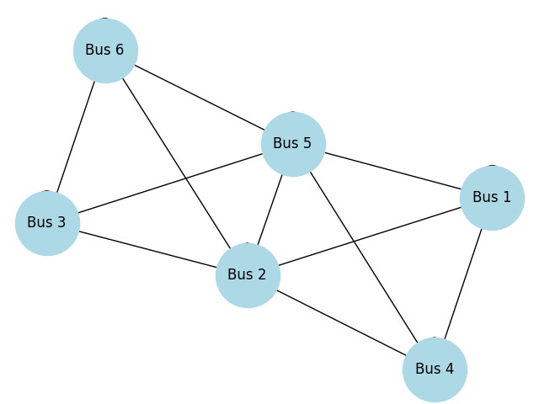

## Power Factor Plot

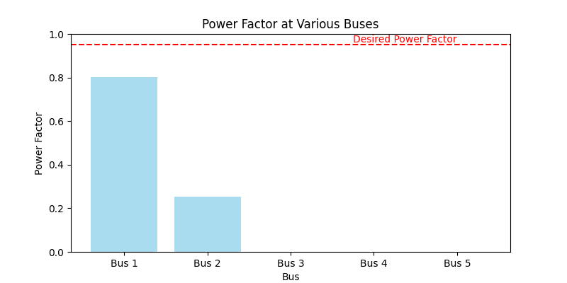

## Voltage Profile Plot

